Chapter 3

Material, Tools & Manufacturing Process in ALUMINA

3.1 Material Used:

3.1.1 Aluminum Sheet (2.5mm thickness): Aluminium or aluminum (in North American English) is a chemical element in the boron group with symbol Al and atomic number 13. It is a silvery-white, soft, nonmagnetic, ductile metal. By mass, aluminium makes up about 8% of the Earth's crust, it is the third most abundant element after oxygen and silicon and the most abundant metal in the crust, though it is less common in the mantle below. Aluminium metal is so chemically reactive that native specimens are rare and limited to extreme reducing environments. Instead, it is found combined in over 270 different minerals. The chief ore of aluminium is bauxite. Aluminium is remarkable for the metal's low density and its ability to resist corrosion through the phenomenon of passivation. Aluminium and its alloys are vital to the aerospace industry and important in transportation and structures, such as building facades and window frames. The oxides and sulfates are the most useful compounds of aluminium.
Despite its prevalence in the environment, no known form of life uses aluminium salts metabolically, but aluminium is well tolerated by plants and animals. Because of these salts' abundance, the potential for a biological role for them is of continuing interest, and studies continue.
3.1.2 Characteristics:
Physical: Aluminum is a relatively soft, durable, lightweight, ductile, and malleable metal with appearance ranging from silvery to dull gray, depending on the surface roughness. It is nonmagnetic and does not easily ignite. A fresh film of aluminium serves as a good reflector (approximately 92%) of visible light and an excellent reflector (as much as 98%) of medium and far infrared radiation. The yield strength of pure aluminium is 7–11 MPa, while aluminium alloys have yield strengths ranging from 200 MPa to 600 MPa. Aluminium has about one-third the density and stiffness of steel. It is easily machined, cast, drawn and extruded.
Aluminium atoms are arranged in a face-centered cubic (fcc) structure. Aluminium has a stacking-fault energy of approximately 200 mJ/m2.
Aluminium is a good thermal and electrical conductor, having 59% the conductivity of copper, both thermal and electrical, while having only 30% of copper's density. Aluminium is capable of superconductivity, with a superconducting critical temperature of 1.2 kelvin and a critical magnetic field of about 100 gauss (10 milliteslas). Aluminium is the most common material for the fabrication of superconducting cubits.
Chemical: Corrosion resistance can be excellent because a thin surface layer of aluminium oxide forms when the bare metal is exposed to air, effectively preventing further oxidation, in a process termed passivation. The strongest aluminium alloys are less corrosion resistant due to galvanic reactions with alloyed copper. This corrosion resistance is greatly reduced by aqueous salts, particularly in the presence of dissimilar metals.
In highly acidic solutions, aluminium reacts with water to form hydrogen, and in highly alkaline ones to form aluminates— protective passivation under these conditions is negligible. Primarily because it is corroded by dissolved chlorides, such as common sodium chloride, household plumbing is never made from aluminium.
However, because of its general resistance to corrosion, aluminium is one of the few metals that retains silvery reflectance in finely powdered form, making it an important component of silver-colour paints. Aluminium mirror finish has the highest reflectance of any metal in the 200–400 nm (UV) and the 3,000–10,000 nm (far IR) regions; in the 400–700 nm visible range it is slightly outperformed by tin and silver and in the 700–3000 nm (near IR) by silver, gold, and copper.
Aluminium is oxidized by water at temperatures below 280 °C to produce hydrogen, aluminium hydroxide and heat:
2 Al + 6 H₂O → 2 Al (OH)₃ + 3 H₂
This conversion is of interest for the production of hydrogen. However, commercial application of this fact has challenges in circumventing the passivation oxide layer, which inhibits the reaction, and in storing the energy required to regenerate the aluminium metal.

3.2 Tools used in the Manufacturing & Design of ALUMINA:
- Scriber
- Glinder
- Drill Bit
- Circular File
- Half Round File
- Screw Driver
- Allen Key
- Plier Plass
- Mallet
- Bench Vise
- Center Punch
3.2.1 Scriber:
A scriber is a hand tool used in metalworking to mark lines on work pieces, prior to machining. The process of using a scriber is called scribing and is just part of the process of marking out. It is used instead of pencils or ink lines, because the marks are hard to see, easily erased, and inaccurate due to their wide mark, scribe lines are thin and semi-permanent. They are a rod with a tip made of cast steel that has been hardened and tempered. The point is sharpened to an angle of 30 or 40 degrees. Some scribers have a point at both ends. It is used by drawing the point over the surface of the work piece to leave a shallow scratch on its surface.
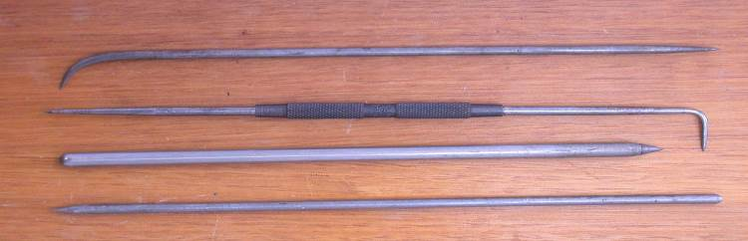
Fig: - 3.1 (Scribers)
3.2.2 Center Punch:
Center punch is used to mark the center of a point. It is usually used to mark the center of a hole when drilling holes. A drill has the tendency to "wander" if it does not start in a recess. A center punch forms a large enough dimple to "guide" the tip of the drill. The tip of a center punch has an angle between 60 and 90 degrees. When drilling larger holes, and the web of the drill is wider than the indentation produced by a center punch, the drilling of a pilot hole is usually needed.
An automatic center punch operates without the need for a hammer.
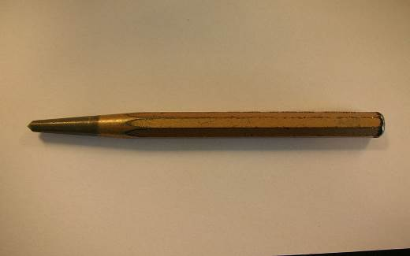
Fig: - 3.2 (Center Punch)
3.2.3 Drill Bit:
Drill bits are cutting tools used to remove material to create holes, almost always of circular cross-section. Drill bits come in many sizes and shape and can create different kinds of holes in many different materials. In order to create holes drill bits are attached to a drill, which powers them to cut through the work piece, typically by rotation. The drill will grasp the upper end of a bit called the shank in the chuck.
Drill bits come in standard sizes, described in the drill bit sizes article. A comprehensive drill bit and tap size chart lists metric and imperial sized drill bits alongside the required screw tap sizes.
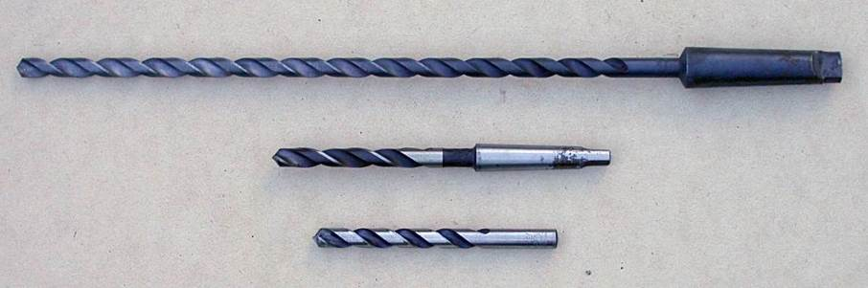
Fig: - 3.3 (Drill Bit)
3.2.4 Circular & Half Round File:
A file is a tool used to remove fine amounts of material from a work piece. It is common in woodworking, metalworking, and other similar trade and hobby tasks. Most are hand tools, made of a case hardened steel bar of rectangular, square, triangular, or round cross-section, with one or more surfaces cut with sharp, generally parallel teeth. A narrow, pointed tang is common at one end, to which a handle may be fitted.
Files have also been developed with abrasive surfaces, such as natural or synthetic diamond grains or silicon carbide, allowing removal of material that would dull or resist metal, such as ceramic.
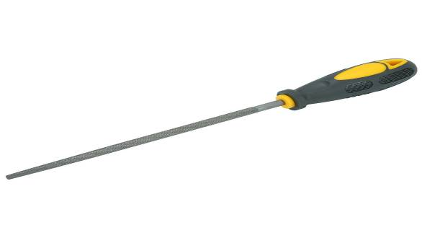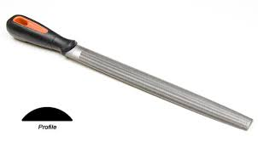
Fig: - 3.4 (Circular file) Fig: - 3.5 (Half Round File)

3.2.5 Screw Driver:
A screwdriver is a tool, manual or powered, for turning (driving or removing) screws. A typical simple screwdriver has a handle and a shaft, and a tip that the user inserts into the screw head to turn it. The shaft is usually made of tough steel to resist bending or twisting. The tip may be hardened to resist wear, treated with a dark tip coating for improved visual contrast between tip and screw or ridged or treated for additional 'grip'. Handles are typically wood, metal, or plastic and usually hexagonal, square, or oval in cross-section to improve grip and prevent the tool from rolling when set down.
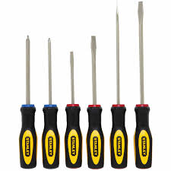
Fig: - 3.6 (Screw Driver)
3.2.6 Allen Key:
A hex key, Allen key or Allen wrench is a tool used to drive bolts and screws with hexagonal sockets in their heads.
The Allen name is a registered trademark, originated by the Allen Manufacturing Company of Hartford, Connecticut circa 1910, and currently owned by Apex Tool Group, LLC. Its generalized use is discouraged by this company. The standard generic name used in catalogues and published books and journals is "hex key".
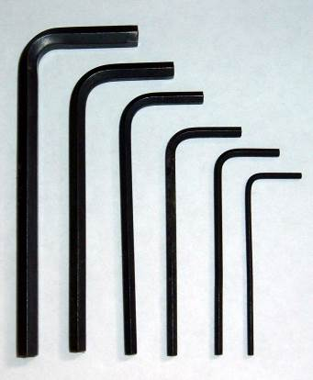
Fig: - 3.7 (Allen Key)
Features:-
- The tool is simple, small and light
- The contact surfaces of the screw or bolt are protected from external damage
- There are six contact surfaces between bolt and driver
- The tool can be used with a headless screw
- The screw can be inserted into its hole using the key
- Torque is constrained by the length and thickness of the key
- Very small bolt heads can be accommodated
- The tool can be manufactured very cheaply, so one is often included with products requiring end-user assembly
- Either end of the tool can be used to take advantage of reach or torque
- The tool is L-shaped
- The tool can be reconditioned using an electric grinder by removing the worn-out part, and then it works like new
- The hexagon is typically a smaller diameter than would be used with an external cap, and is more likely to round off its contact surfaces.
- It is much more difficult to turn a damaged (rounded or otherwise) internal fastener than an external one.

3.2.7 Plier Plass:
Pliers plass are a hand tool used to hold objects firmly, possibly developed from tongs used to handle hot metal in Bronze Age Europe. They are also useful for bending and compressing a wide range of materials. Generally, pliers consist of a pair of metal first-class levers joined at a fulcrum positioned closer to one end of the levers, creating short jaws on one side of the fulcrum, and longer handles on the other side. This arrangement creates a mechanical advantage, allowing the force of the hand's grip to be amplified and focused on an object with precision. The jaws can also be used to manipulate objects too small or unwieldy to be manipulated with the fingers.
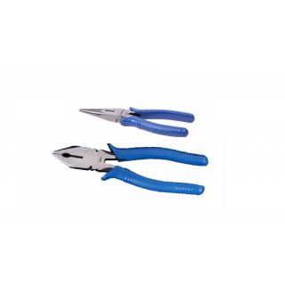
Fig: - 3.8 (Plier Plass)

3.2.8 Mallet:
A mallet is a kind of hammer, often made of rubber or sometimes wood, that is smaller than a maul or beetle, and usually has a relatively large head. The term is descriptive of the overall size and proportions of the tool, and not the materials it may be made of, though most mallets have striking faces that are softer than steel.
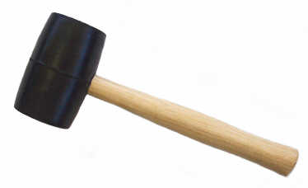
Fig: - 3.9 (Mallet)
3.2.9 Bench Vise:
Woodworking vises are attached to a workbench, typically flush with its work surface. Their jaws are made of wood or metal, the latter usually faced with wood, called cheeks, to avoid marring the work.^{[1]} The movable jaw may include a retractable dog to hold work against a bench dog.
"Quick-release" vises employ a split nut that allows the screw to engage or disengage with a half-turn of the handle. When disengaged the movable jaw may be moved in or out throughout its entire range of motion, vastly speeding up the process of adjustment. Common thread types are Acme and buttress.
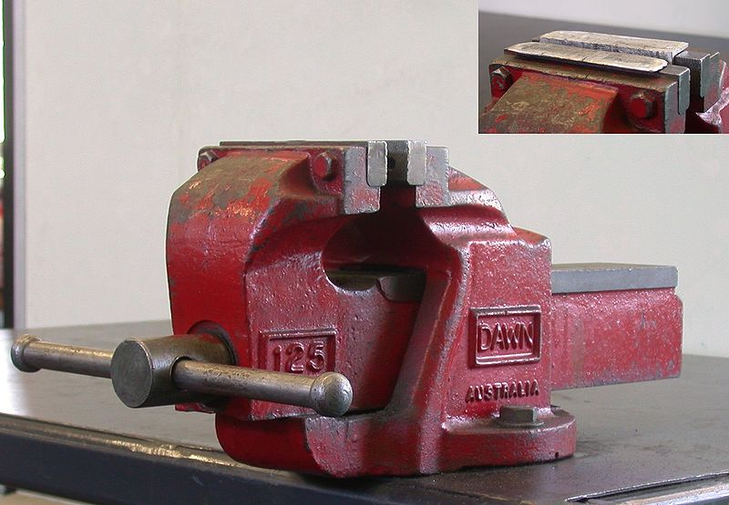
Fig: - 3.10 (Bench Vise)

